|  |  |  |  |  |  |  |  |  |  |  |  |
| --- | --- | --- | --- | --- | --- | --- | --- | --- | --- | --- | --- |
| Data Structure | Time Complexity | | | | | | | | | Space | |
|  | Average | | | | Worst | | | | | Worst | |
|  | Access | Search | Insertion | Deletion | Access | Search | Insertion | Deletion |  | |
| [Array](http://en.wikipedia.org/wiki/Array_data_structure) | Θ(1) | Θ(n) | Θ(n) | Θ(n) | O(1) | O(n) | O(n) | O(n) | O(n) | |
| [Stack](http://en.wikipedia.org/wiki/Stack_(abstract_data_type)) | Θ(n) | Θ(n) | Θ(1) | Θ(1) | O(n) | O(n) | O(1) | O(1) | O(n) | |
| [Queue](http://en.wikipedia.org/wiki/Queue_(abstract_data_type)) | Θ(n) | Θ(n) | Θ(1) | Θ(1) | O(n) | O(n) | O(1) | O(1) | O(n) | |
| [Singly-Linked List](http://en.wikipedia.org/wiki/Singly_linked_list#Singly_linked_lists) | Θ(n) | Θ(n) | Θ(1) | Θ(1) | O(n) | O(n) | O(1) | O(1) | O(n) | |
| [Doubly-Linked List](http://en.wikipedia.org/wiki/Doubly_linked_list) | Θ(n) | Θ(n) | Θ(1) | Θ(1) | O(n) | O(n) | O(1) | O(1) | O(n) | |
| [Hash Table](http://en.wikipedia.org/wiki/Hash_table) | N/A | Θ(1) | Θ(1) | Θ(1) | N/A | O(n) | O(n) | O(n) | O(n) | |
| [Binary Search Tree](http://en.wikipedia.org/wiki/Binary_search_tree) | Θ(log(n)) | Θ(log(n)) | Θ(log(n)) | Θ(log(n)) | O(n) | O(n) | O(n) | O(n) | O(n) | |
| [AVL Tree](http://en.wikipedia.org/wiki/AVL_tree) | Θ(log(n)) | Θ(log(n)) | Θ(log(n)) | Θ(log(n)) | O(log(n)) | O(log(n)) | O(log(n)) | O(log(n)) | O(n) | |

|  |  |  |  |  |
| --- | --- | --- | --- | --- |
| Algorithm | Time Complexity | | | Space |
|  | Best | Average | Worst | Worst |
| [Quicksort](http://en.wikipedia.org/wiki/Quicksort) | Ω(n log(n)) | Θ(n log(n)) | O(n^2) | O(log(n)) |
| [Mergesort](http://en.wikipedia.org/wiki/Merge_sort) | Ω(n log(n)) | Θ(n log(n)) | O(n log(n)) | O(n) |
| [Heapsort](http://en.wikipedia.org/wiki/Heapsort) | Ω(n log(n)) | Θ(n log(n)) | O(n log(n)) | O(1) |
| [Insertion Sort](http://en.wikipedia.org/wiki/Insertion_sort) | Ω(n) | Θ(n^2) | O(n^2) | O(1) |
| [Selection Sort](http://en.wikipedia.org/wiki/Selection_sort) | Ω(n^2) | Θ(n^2) | O(n^2) | O(1) |

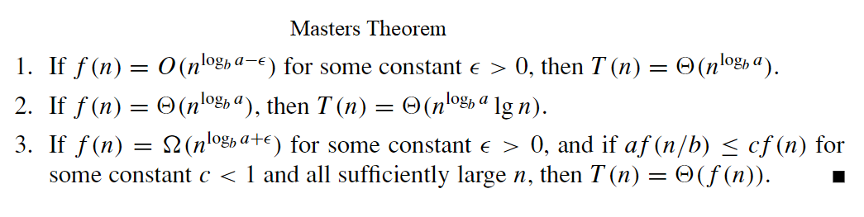 Build Max Heap = O(n)

**AVL Tree:**

min height = log2N ; max height = 1.44* log2N

max nodes possible with height h = 2h+1 -1

min nodes with height h = N(h) = N(h-1) + N(h-2) +1

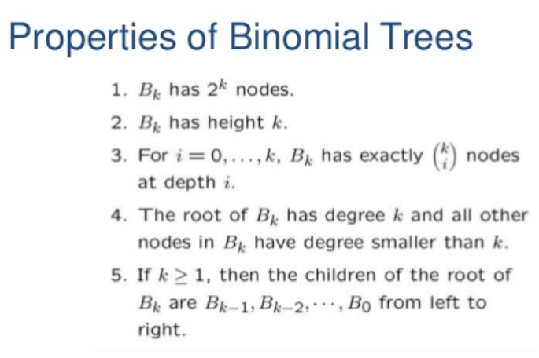Binomial heap is set of binomial trees each obeying min heap property

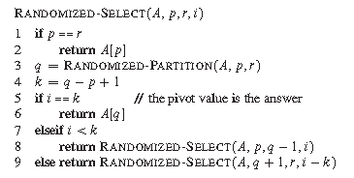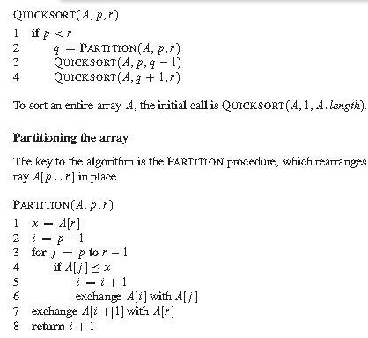if f(n) = theta(nlogb(a)*(log(n))k ) : then T(n) = nlogb(a)*log(n)k+1

is O(logn)

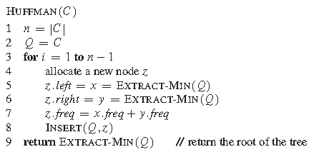

j